Customer Segmentation Analysis and Brand Affluence

After data cleaning, the resulting total sales showed that most of the sales came from Budget - Older families, Mainstream - young singles/couples and Mainstream - retirees.

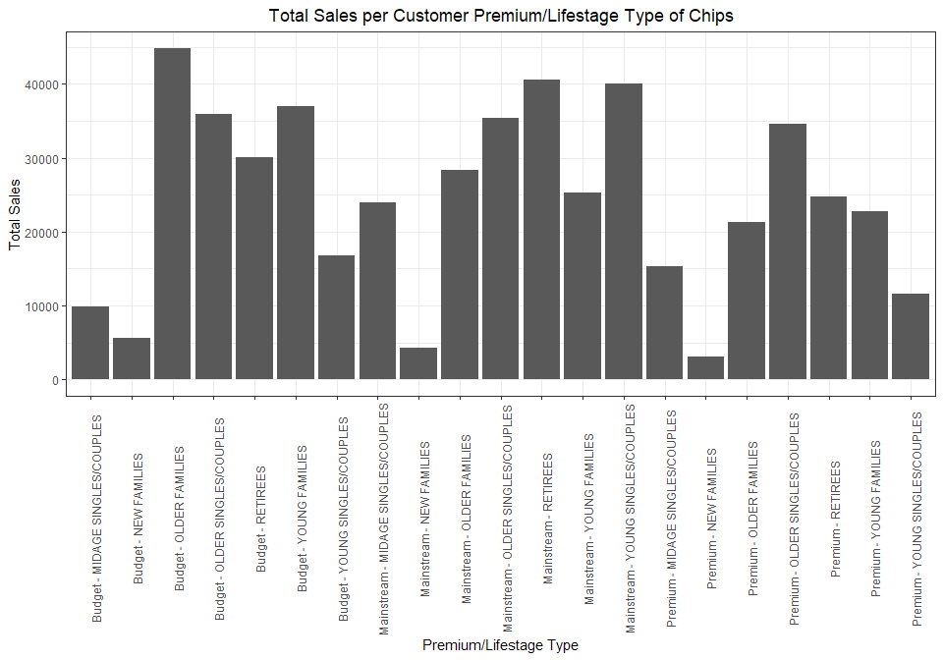

But, to truly find the performance of a certain customer segment, the average sales per transaction would describe better which segment likes to spend more on chips.

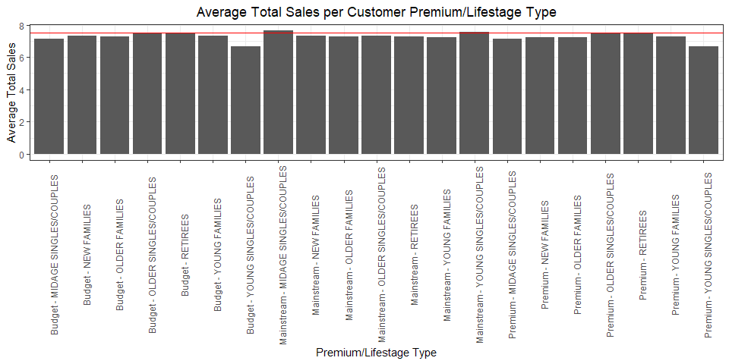

Based on the prior graph, Mainstream midage and young singles/couples spend the most on average on chips per transaction.

This implies that this demographic should be the segment we should focus on to increase sales with. We can do this by looking at brand affiliation.

The top 8 brands for the data would be "Kettle", "Smiths", "Pringles", "Doritos", "Infzns" "Thins", "RRD", and "WW".

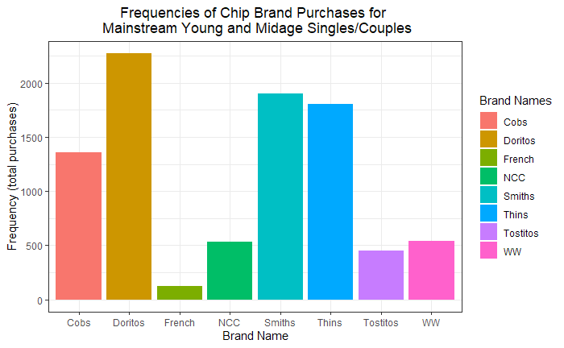

The frequency graph shows that Doritos, Smiths, and Thins are the most popular brands for this customer segment. This suggests to increase the supply for those three brands.

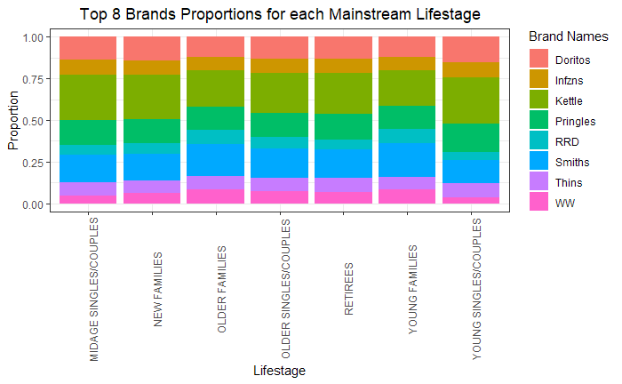

This graph showcases the proportions for each Mainstream lifestage customer segment.

Trial Performance

To discern whether the trial period positively impacted the specifed trial stores (77, 86, and 88), we needed to find control stores that weren’t affected by the trial. These control stores were chosen based on their performance over the period and whether it was similar to the performance of the trial stores. The control stores for 77, 86, and 88 are: 233, 155, and 237. Then, the control stores’ sales were standardized and scaled to fit to the trial stores. This way, we can directly compare their performance on the same scale. The following graphs show the performance of each store.

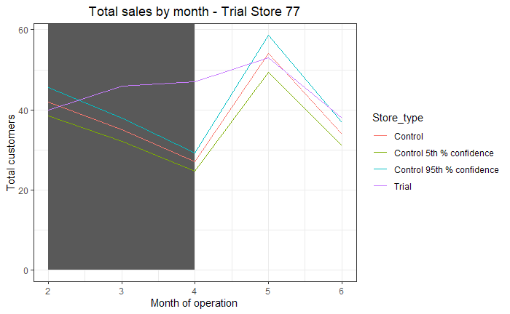

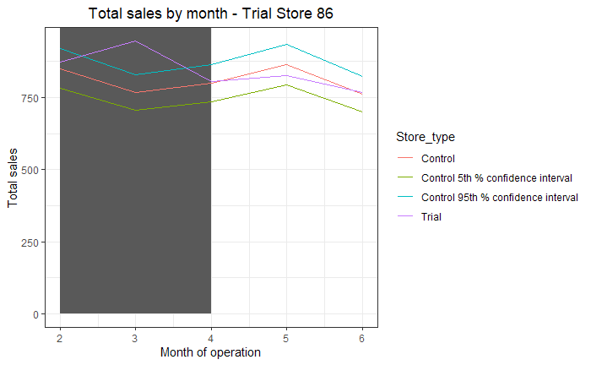

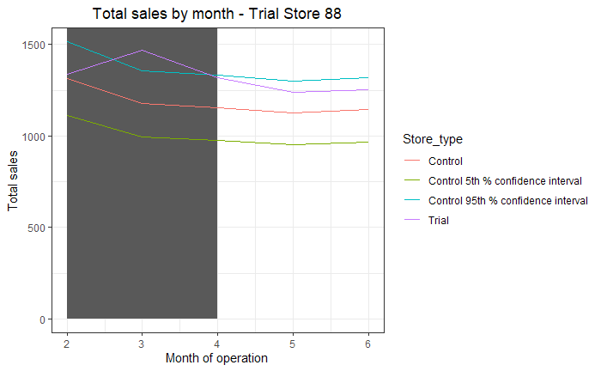

Each store showed a statistically significant increase in sales during the trial month. This shows the trial was successful in increasing general sales in chips.